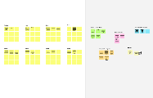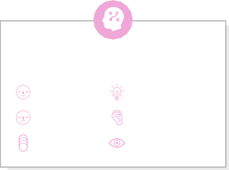

# Before you collaborate

**Template**

A little bit of preparation goes a long way with this session. Here’s what you need to do to get going.

**10 minutes**

**1**

# Define your problem statement

What problem are you trying to solve? Frame your problem as a How Might We statement. This will be the focus of your brainstorm.

**5 minutes**

# 2

**Brainstorm**

Write down any ideas that come to mind that address your problem statement.

**10 minutes**

# 4

**Prioritize**

**3**

**Group ideas**

Take turns sharing your ideas while clustering similar or related notes as you go. In the last 10 minutes, give each cluster a sentence-like label. If a cluster is bigger than six sticky notes, try and see if you and break it up into smaller sub-groups.

**20 minutes**

Your team should all be on the same page about what's important moving forward. Place your ideas on this grid to determine which ideas are important and which are feasible.

**20 minutes**

**PROBLEM**

**How might we [your problem statement]?**

# After you collaborate

You can export the mural as an image or pdf to share with members of your company who might find it helpful.

Brainstorm

& idea prioritization

Use this template in your own brainstorming sessions so your team can unleash their imagination and start shaping concepts even if you're not sitting in the same room.

1. **Team gathering**

Define who should participate in the session and send an invite. Share relevant information or pre-work ahead.

1. **Set the goal**

Think about the problem you'll be focusing on solving in the brainstorming session.

1. **Learn how to use the facilitation tools**

Use the Facilitation Superpowers to run a happy and productive session.

A.ABUZAR

**TIP**

Add customizable tags to sticky notes to make it easier to find, browse, organize, and categorize important ideas as themes within your mural.

|  |  |  |
| --- | --- | --- |
| poltics news | educational news | health news |
| share market news | collection of news | crime news |
| gadgets news | sports news | cinema news |

D.BUVAN KISHORE

|  |  |  |
| --- | --- | --- |
| press release or handout | press conference | interview |
| legislatures news | sources of  news from press | court news |
| offical reports | conference news | seminar symposia news |

**P.RAHUL**

|  |  |  |
| --- | --- | --- |
| some apps demand premium subscription | accurance of  advertisemen | fake and uncertain news |
| only brief info of news | drawbacks | mb size is larger |
| page layout is uncatchy | interface is not good enough | some categories of news are missing |

S.SUNEEL

|  |  |  |
| --- | --- | --- |
| fash news | news according to your interest | detection of fake news |
| autoplay videos | developement ieads for exsisting app | read ofine |
| news in 60 words | reduce the mb size | live news |

**Quick add-ons**

**TIP**

You can select a sticky note and hit the pencil [switch to sketch] icon to start drawing!

* 1. **Share the mural**

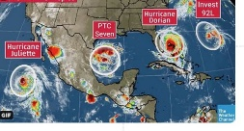

|  |  |  |  |  |  |  |
| --- | --- | --- | --- | --- | --- | --- |
|  | | | | | | |
|  |  |  |  |  |  |  |
|  |  |  |  |  |  |
|  |  |  |  |  |  |
|  |  |  |  |  |  |
|  |  |  |  |  |  |
|  |  |  |  |  |  |

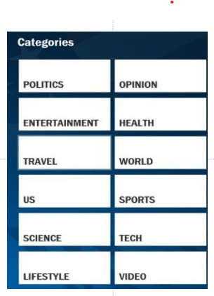**Share a view link** to the mural with stakeholders to keep them in the loop about the outcomes of the session.

* 1. **Export the mural**

Export a copy of the mural as a PNG or PDF to attach to emails, include in slides, or save in your drive.

**10 minutes** to prepare

**1 hour** to collaborate

**2-8 people** recommended

[**Open article**](https://support.mural.co/en/articles/2113740-facilitation-superpowers)

Advantages

# Key rules of brainstorming

get local news from your community

top news headlines

To run an smooth and productive session

# Keep moving forward

**Strategy blueprint**

Define the components of a new idea or strategy.

[**Open the template**](https://app.mural.co/template/e95f612a-f72a-4772-bc48-545aaa04e0c9/984865a6-0a96-4472-a48d-47639307b3ca)

Stay in topic.

Defer judgment.

Encourage wild ideas.

Listen to others.

# Importance

stay updated across all your devices

**Customer experience journey map**

Understand customer needs, motivations, and obstacles for an experience.

[**Open the template**](https://app.mural.co/template/b7114010-3a67-4d63-a51d-6f2cedc9633f/c1b465ab-57af-4624-8faf-ebb312edc0eb)

[**Share template feedback**](https://muralco.typeform.com/to/CiqaHVat?typeform-source=app.mural.co)

Go for volume. If possible, be visual.

If each of these tasks could get done without any difficulty or cost, which would have the most positive impact?

Disadvantages



# Feasibility

Regardless of their importance, which tasks are more feasible than others? (Cost, time, effort, complexity, etc.)

**Strengths, weaknesses, opportunities & threats**

Identify strengths, weaknesses, opportunities, and threats (SWOT) to develop a plan.

|  |  |
| --- | --- |
|  |  |
|  |  |

[**Open the template**](https://app.mural.co/template/6a062671-89ee-4b76-9409-2603d8b098be/ca270343-1d54-4952-9d8c-fbc303ffd0f2)

[**Share template feedback**](https://muralco.typeform.com/to/CiqaHVat?typeform-source=app.mural.co)

no catagories for old new

fake news may mislead the

readers

to reduce the mb size

**Need some inspiration?**

See a finished version of this template to kickstart your work.

[**Open example**](https://app.mural.co/template/e5a93b7b-49f2-48c9-afd7-a635d860eba6/93f1b98d-b2d2-4695-8e85-7e9c0d2fd9b9)